Installation of Apache2

Apache is Web server that runs DVWA, listens for incoming HTTP requests from users (e.g., when you visit http[:]//localhost/dvwa), delivers web pages and files to their browsers, and processes scripts like PHP pages which DVWA uses.

Apache2 was installed running the command: sudo apt-get -y install apache2  
The server was started by running the command: sudo systemctl start apache2  
To confirm if it was running: sudo systemctl status apache2 --no-pager and also used the browser. Below is the output confirming the installation of Apache2.

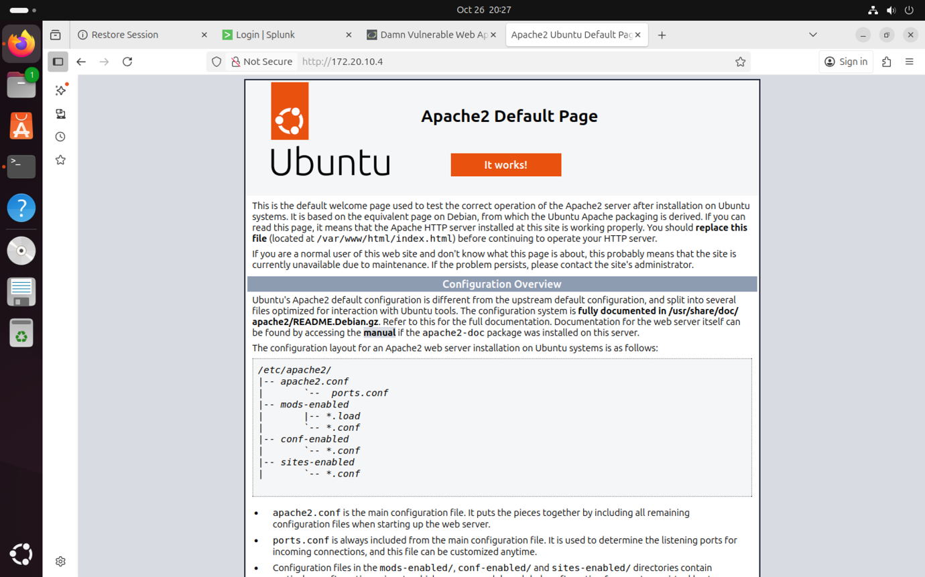

Installation of MariaDB

MariaDB is a database server that stores all DVWA data like users, comments, and vulnerabilities. This database server was installed, secured (setting root password, removing anonymous users etc.) and the service was started.

To install: sudo apt-get -y install mariadb-server

To start the server and enable it to start automatically: sudo systemctl start mariadb && sudo systemctl enable mariadb

Securing of database server: sudo mysql_secure_installation

Installation of PHP and required extensions

PHP is the language that makes DVWA dynamic, it’s the “engine” where vulnerabilities exist.

Php and extensions were installed by running the command: sudo apt-get -y install php php-mysqli php-gd php-xml php-mbstring php-curl php-zip libapache2-mod-php.

Apache 2 was restarted to **reload its configuration and modules** including the new **PHP module** before it can process .php files correctly. What happens when this is done:

* Apache now recognizes .php files.
* When a user requests a .php page (like login.php):

1. Apache receives the HTTP request.
2. It sees .php and sends it to the PHP interpreter.
3. PHP executes the code and returns HTML to Apache.
4. Apache sends that HTML to the browser.

Downloading of DVWA into Apache web directory

Damn Vulnerable Web Application is a deliberately insecured PHP web application designed **for learning and testing web-application security**.

The DVWA repo was cloned into /var/www/html running the command sudo git clone https://github.com/digininja/DVWA.git

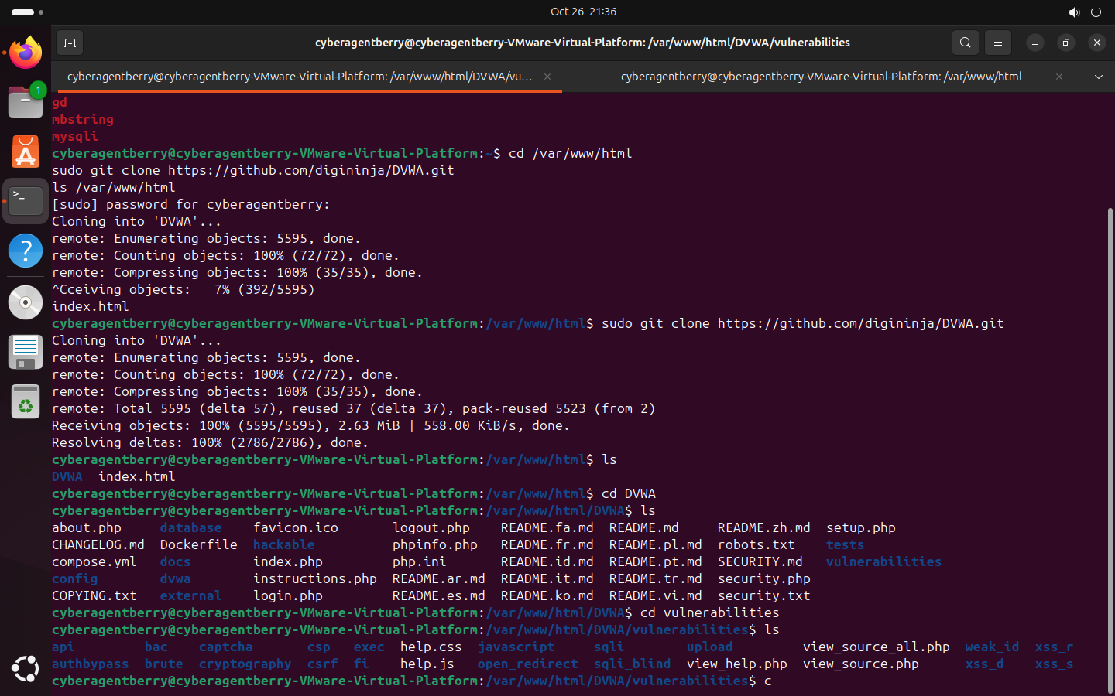

Once the repo was cloned, I went ahead to:

Make the web server user own the DVWA files so Apache/PHP can read/write where needed:  
 sudo chown -R www-data:www-data /var/www/html/DVWA; www-data is the Apache user.  
The sample configuration file was copied into the active configuration file and writable permissions was granted:

cd /var/www/html/DVWA/config

sudo cp config.inc.php.dist config.inc.php

The DB credentials was configured (config.inc.php), DB and user was created using MariaDB CL

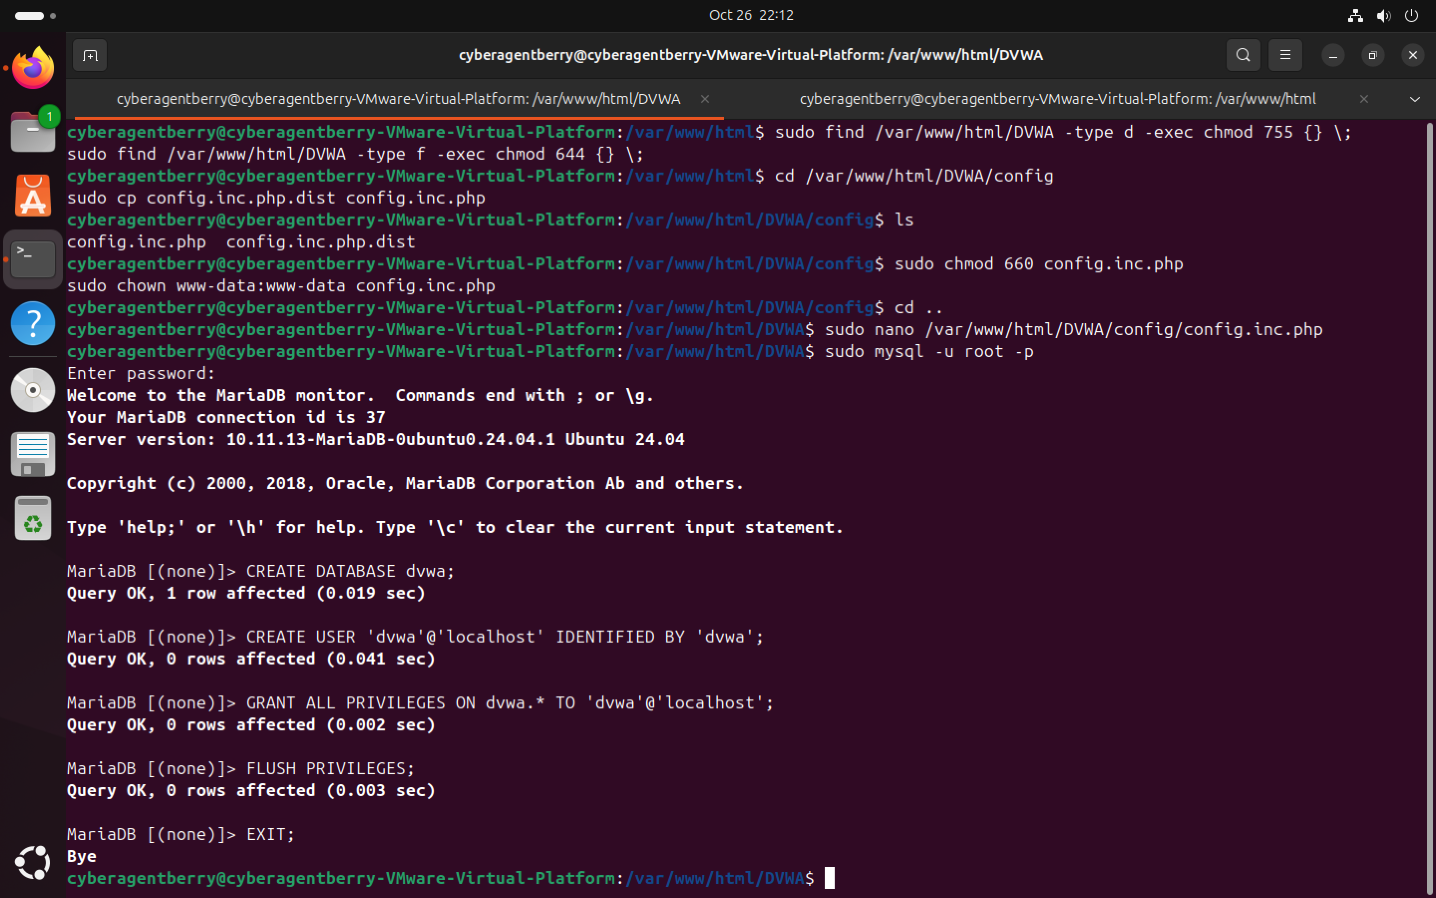

A quick connection test was conducted to confirm connection as a user.  
 mysql -u dvwa -p -h localhost dvwa

mysql -u dvwa -p -h 127.0.0.1 dvwa

And apache2 was reloaded to ensure configurations are loaded in: sudo systemctl restart apache2  
The DVWA was accessed via the web browser and the database schema was created using the “Create / Reset Database” option.

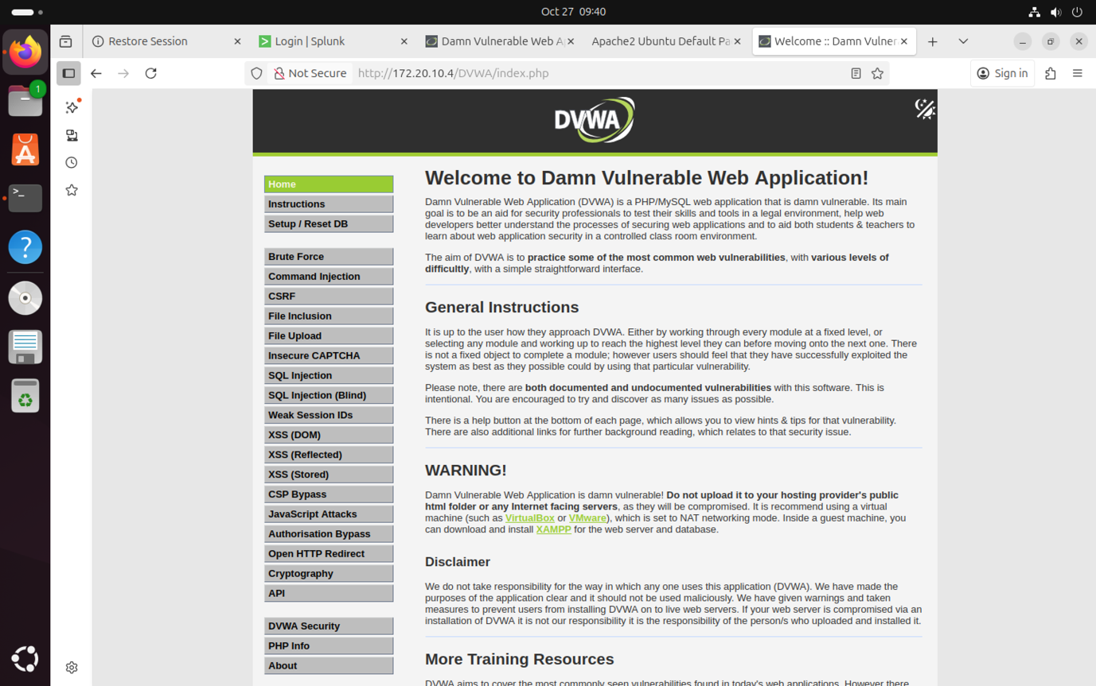

This confirms that the DVWA web application successfully connected to the MariaDB database and initialized the required tables.

Installation and Configuration of ModSecurity

**ModSecurity** is an open-source web application firewall (WAF) that works as a **security module inside Apache**. It inspects incoming HTTP requests like form submissions or URL queries and blocks malicious payloads such as SQL injection (' OR 1=1 --) or XSS (<script>alert(1)</script>).

ModSecurity was installed as an Apache module by running sudo apt-get install libapache2-mod-security2 -y

After enabling the security2 module (sudo a2enmod security2), Apache was restarted successfully.  
The presence of security2_module (shared) in the Apache module list confirms that ModSecurity was correctly loaded and active.

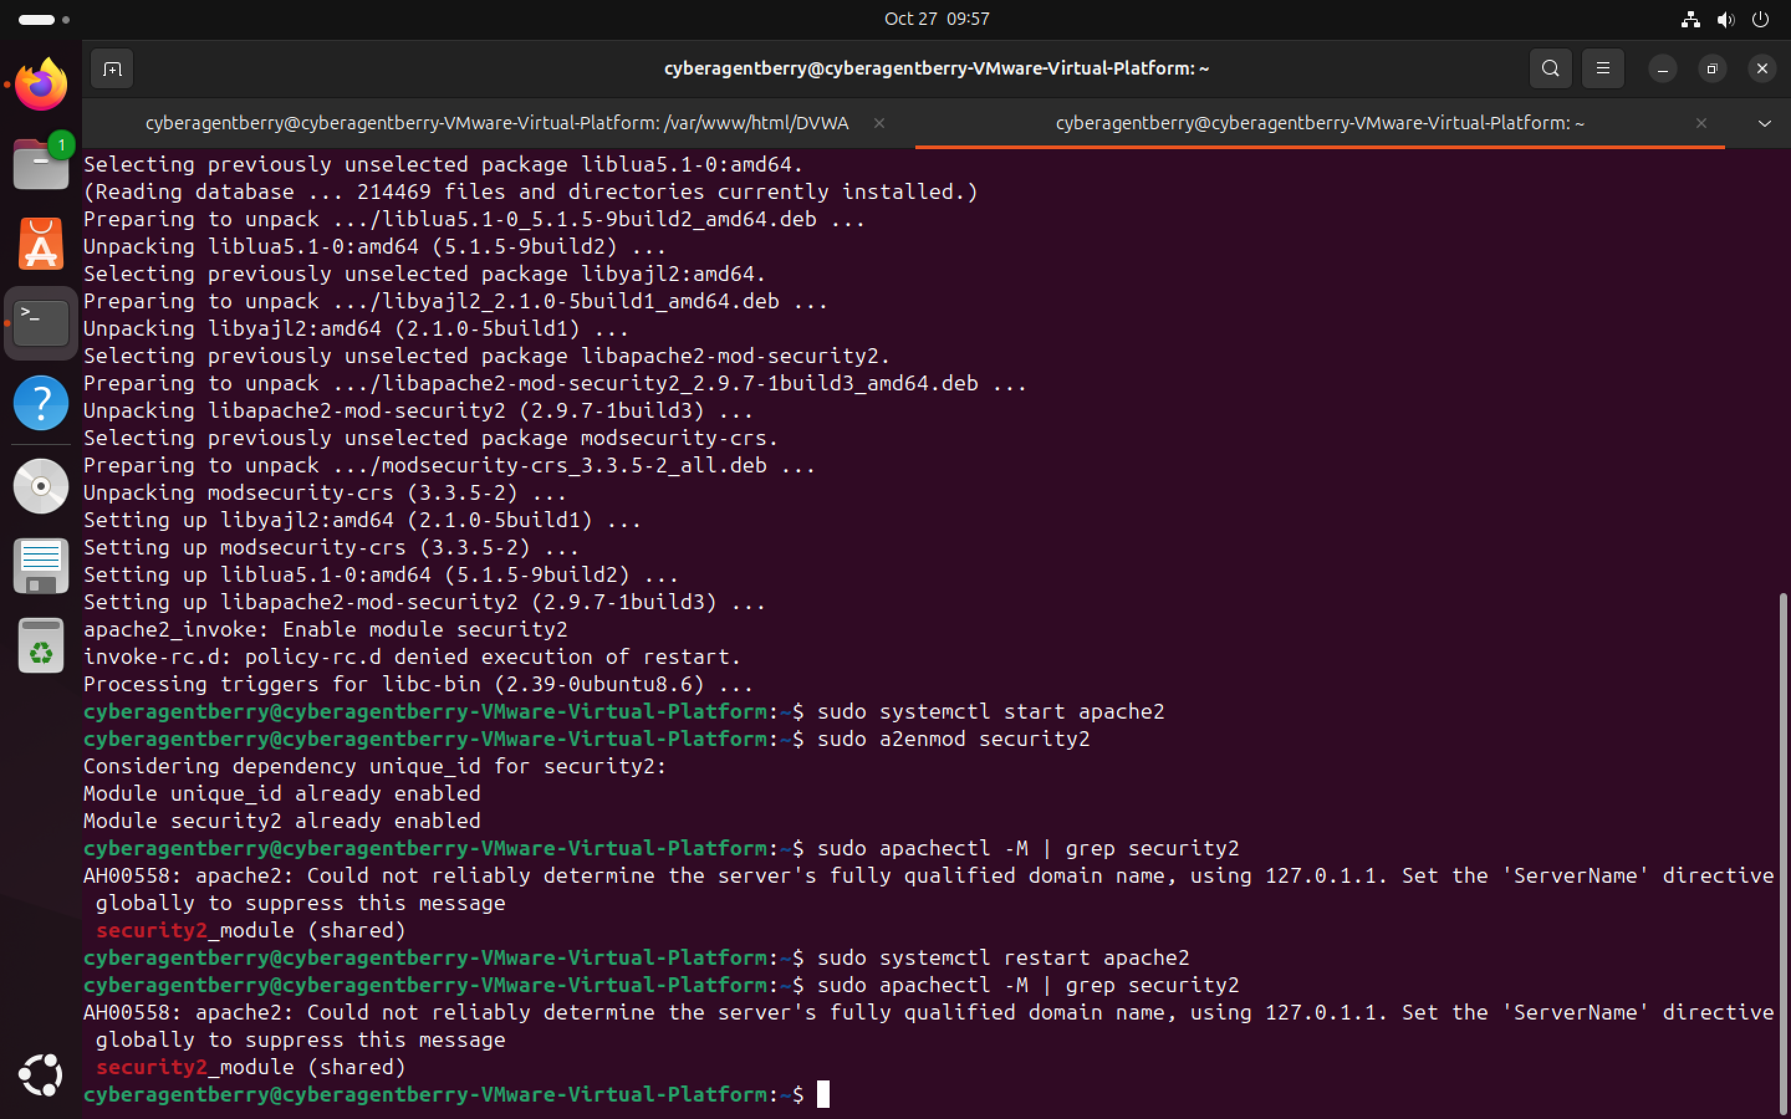

Since ModSecurity was installed, it was **not actively monitoring or logging traffic** yet. To monitor and detect it was now enabled in  a **Detection Only mode**.

Addition of OWASP Core Rule Set

The **OWASP Core Rule Set (CRS)** provides a set of prebuilt ModSecurity rules that detect common web attacks like:

* SQL Injection (SQLi)
* Cross-Site Scripting (XSS)
* Command Injection
* Local File Inclusion (LFI)
* Remote File Inclusion (RFI) etc.

By adding the CRS, this gives the WAF (Web Application Firewall) a strong baseline before writing the **custom rules**.

To begin, I navigated to the /usr/share/ directory and cloned the official OWASP CRS repository from GitHub using the following commands:

cd /usr/share/

sudo git clone https[:]//github.com/coreruleset/coreruleset.git

After cloning the folder coreruleset was renamed to owasp-crs and the crs configuration file in owasp-crs was activated by coping the example set-up file. The Modsecurity configuration file was opened to link the CRS with Apache2 using the command:  
 sudo nano /etc/apache2/mods-enabled/security2.conf

Inside the file, these paths were added to ensure that the CRS rules loads automatically when Modsecurity is added:  
 IncludeOptional /etc/modsecurity/crs/crs-setup.conf

IncludeOptional /etc/modsecurity/crs/rules/*.conf

After saving the configuration, the Apache service was restarted to apply the changes.  
  
Verification:

After configuring ModSecurity and linking the OWASP Core Rule Set (CRS) to Apache, I verified that the module loaded correctly by checking the Apache error logs using:

sudo tail -n 20 /var/log/apache2/error.log.1

the output:

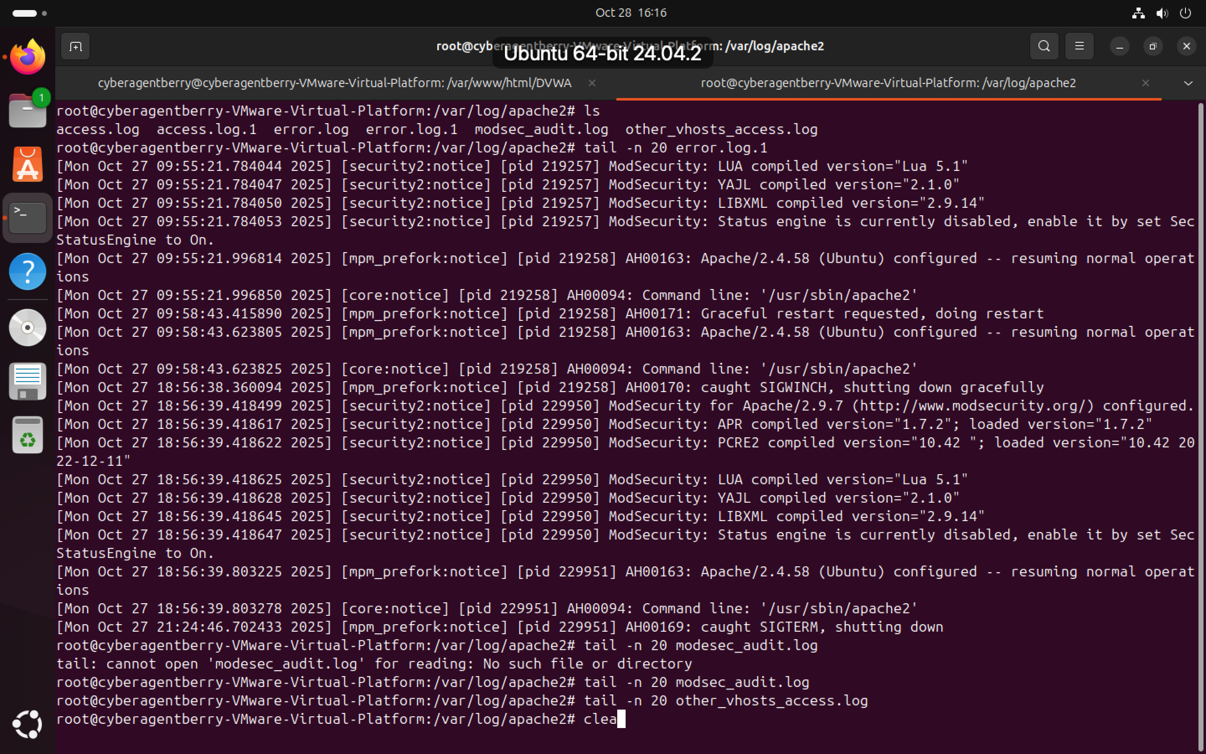

These entries confirmed that:

* **ModSecurity was successfully loaded** into Apache with all its dependencies (LUA, YAJL, LIBXML).
* The **Apache web service** resumed normal operation after the WAF module initialization.
* The notice SecStatusEngine is currently disabled indicates that status reporting is off by default, though this is expected and it is not an error.

Baseline attacks (SQLi & XSS) against DVWA to confirm the WAF is detecting and logging them.

A live logging was started using: sudo tail F /var/log/apache2/modsec_audit.log /var/log/apache2/error.log

In the browser, open DVWA was open and the Security level was set to **Low** and then navigated to the target page (e.g., SQLi: /DVWA/vulnerabilities/sqli/, XSS reflected: /DVWA/vulnerabilities/xss_r/) and the payload was entered.  
  
SQL Injection – Test Case

* **Target:** /DVWA/vulnerabilities/sqli/
* **Security level:** Low
* **Payload used:** 1' OR '1'='1' –

Procedure: Submitted the payload in the id parameter via the DVWA UI while ModSecurity was in DetectionOnly.

Logs were captured from /var/log/apache2/modsec_audit.log and /var/log/apache2/error.log.

DVWA returned user records indicating a successful injection.

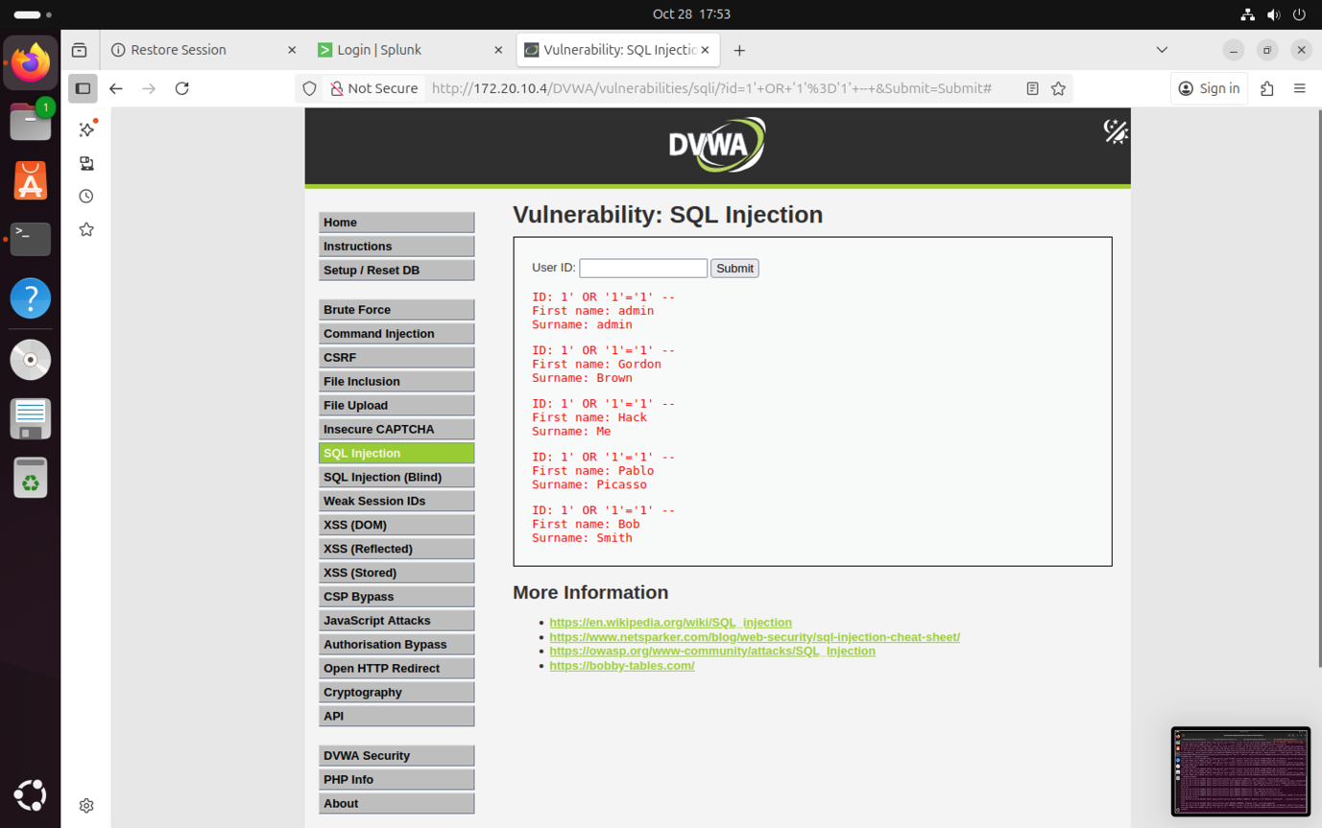

Logs from /var/log/apache2/error.log

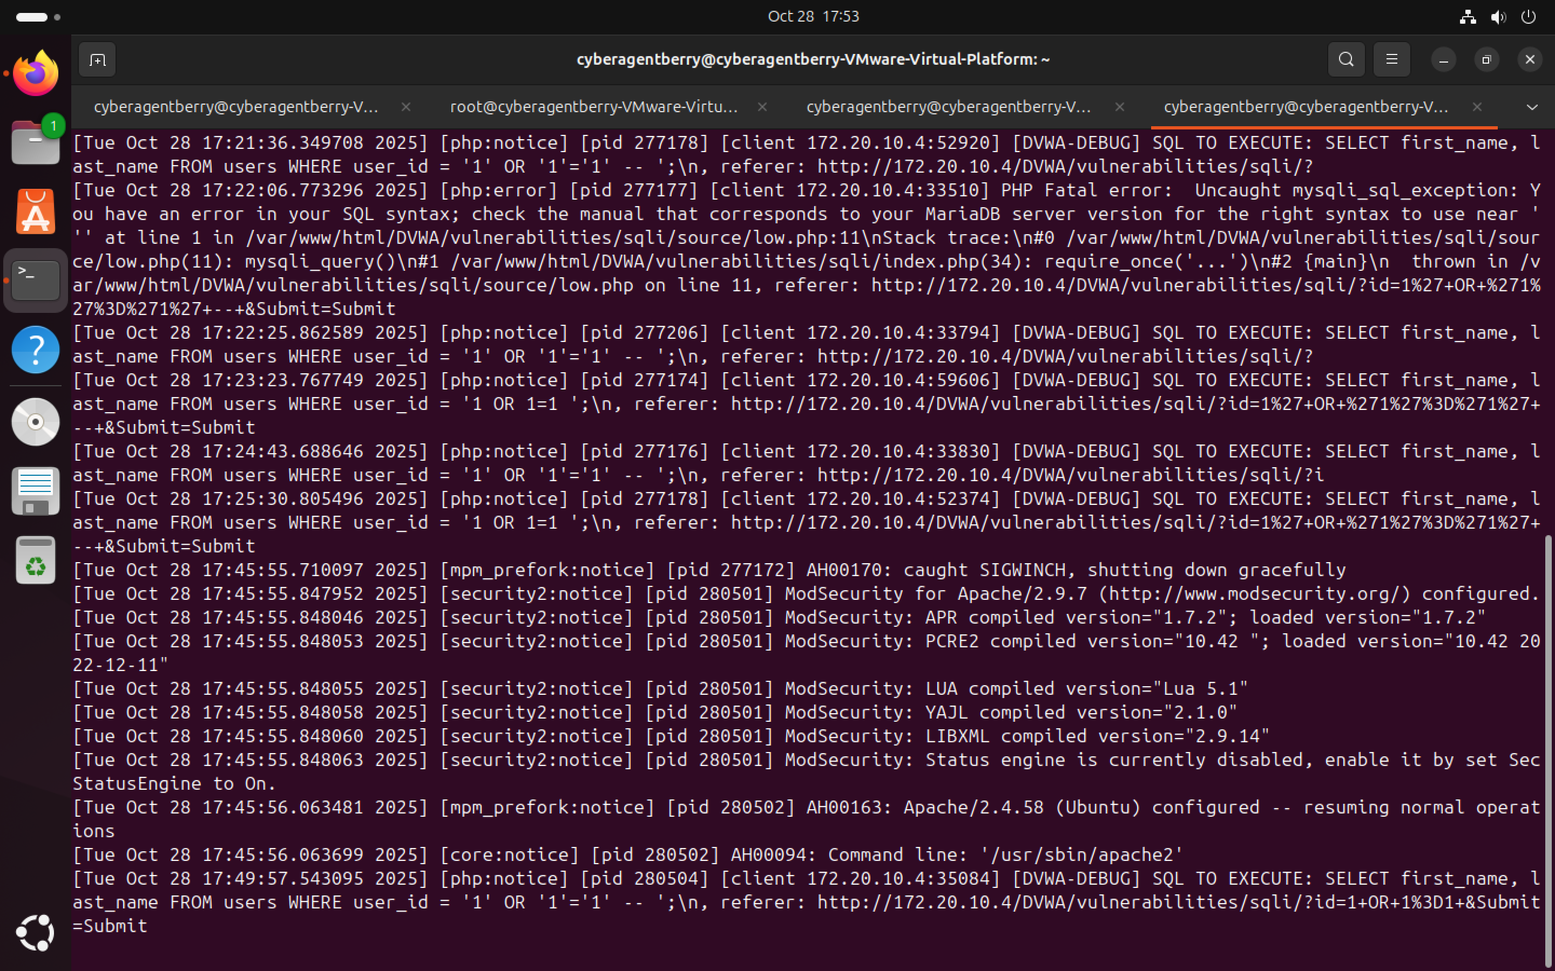

Logs from /var/log/apache2/modsec_audit.log

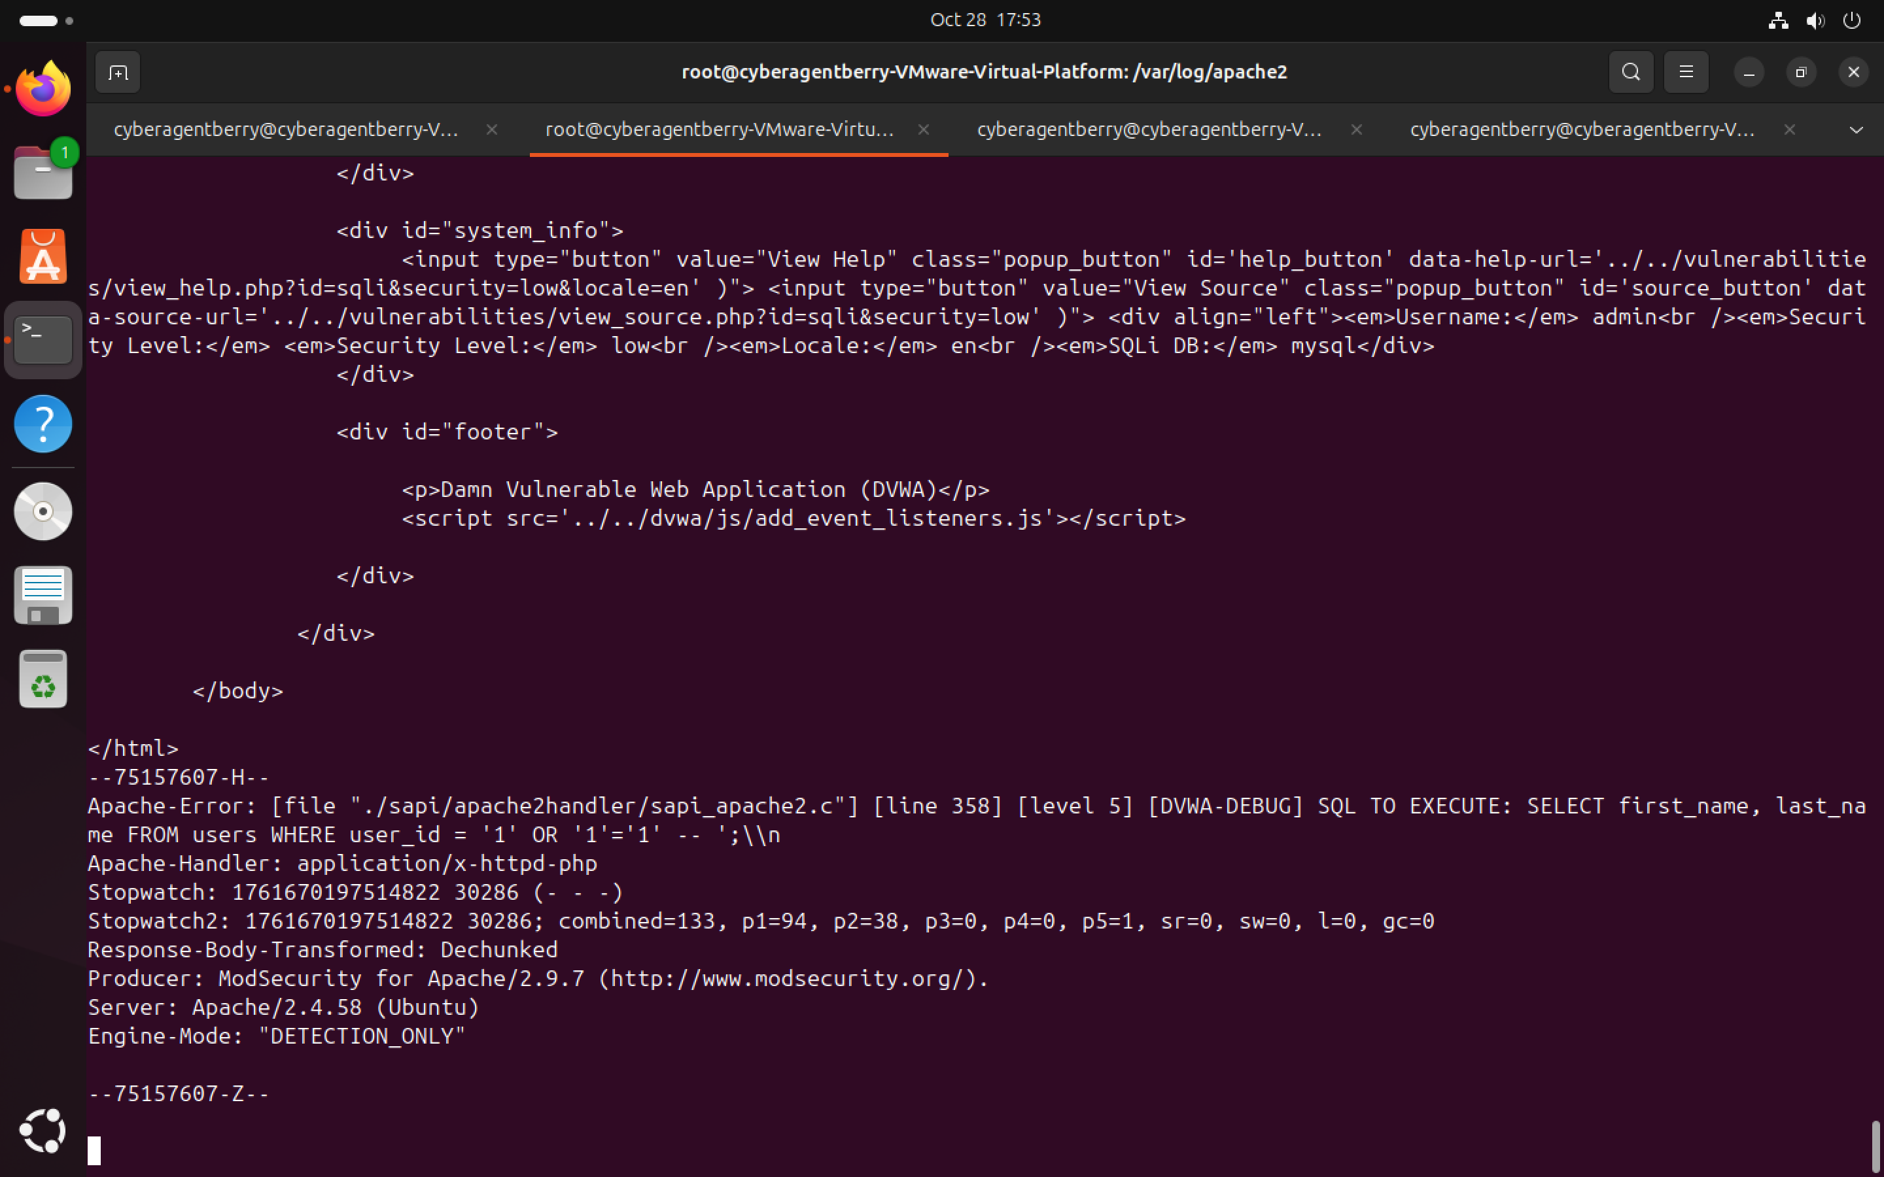

**Baseline XSS tests (reflected):** DVWA’s XSS pages was tested at Low security using payloads <script>alert('XSS')</script> (reflected). The reflected payload executed immediately in the browser. And modsecurity audit logs were captured.

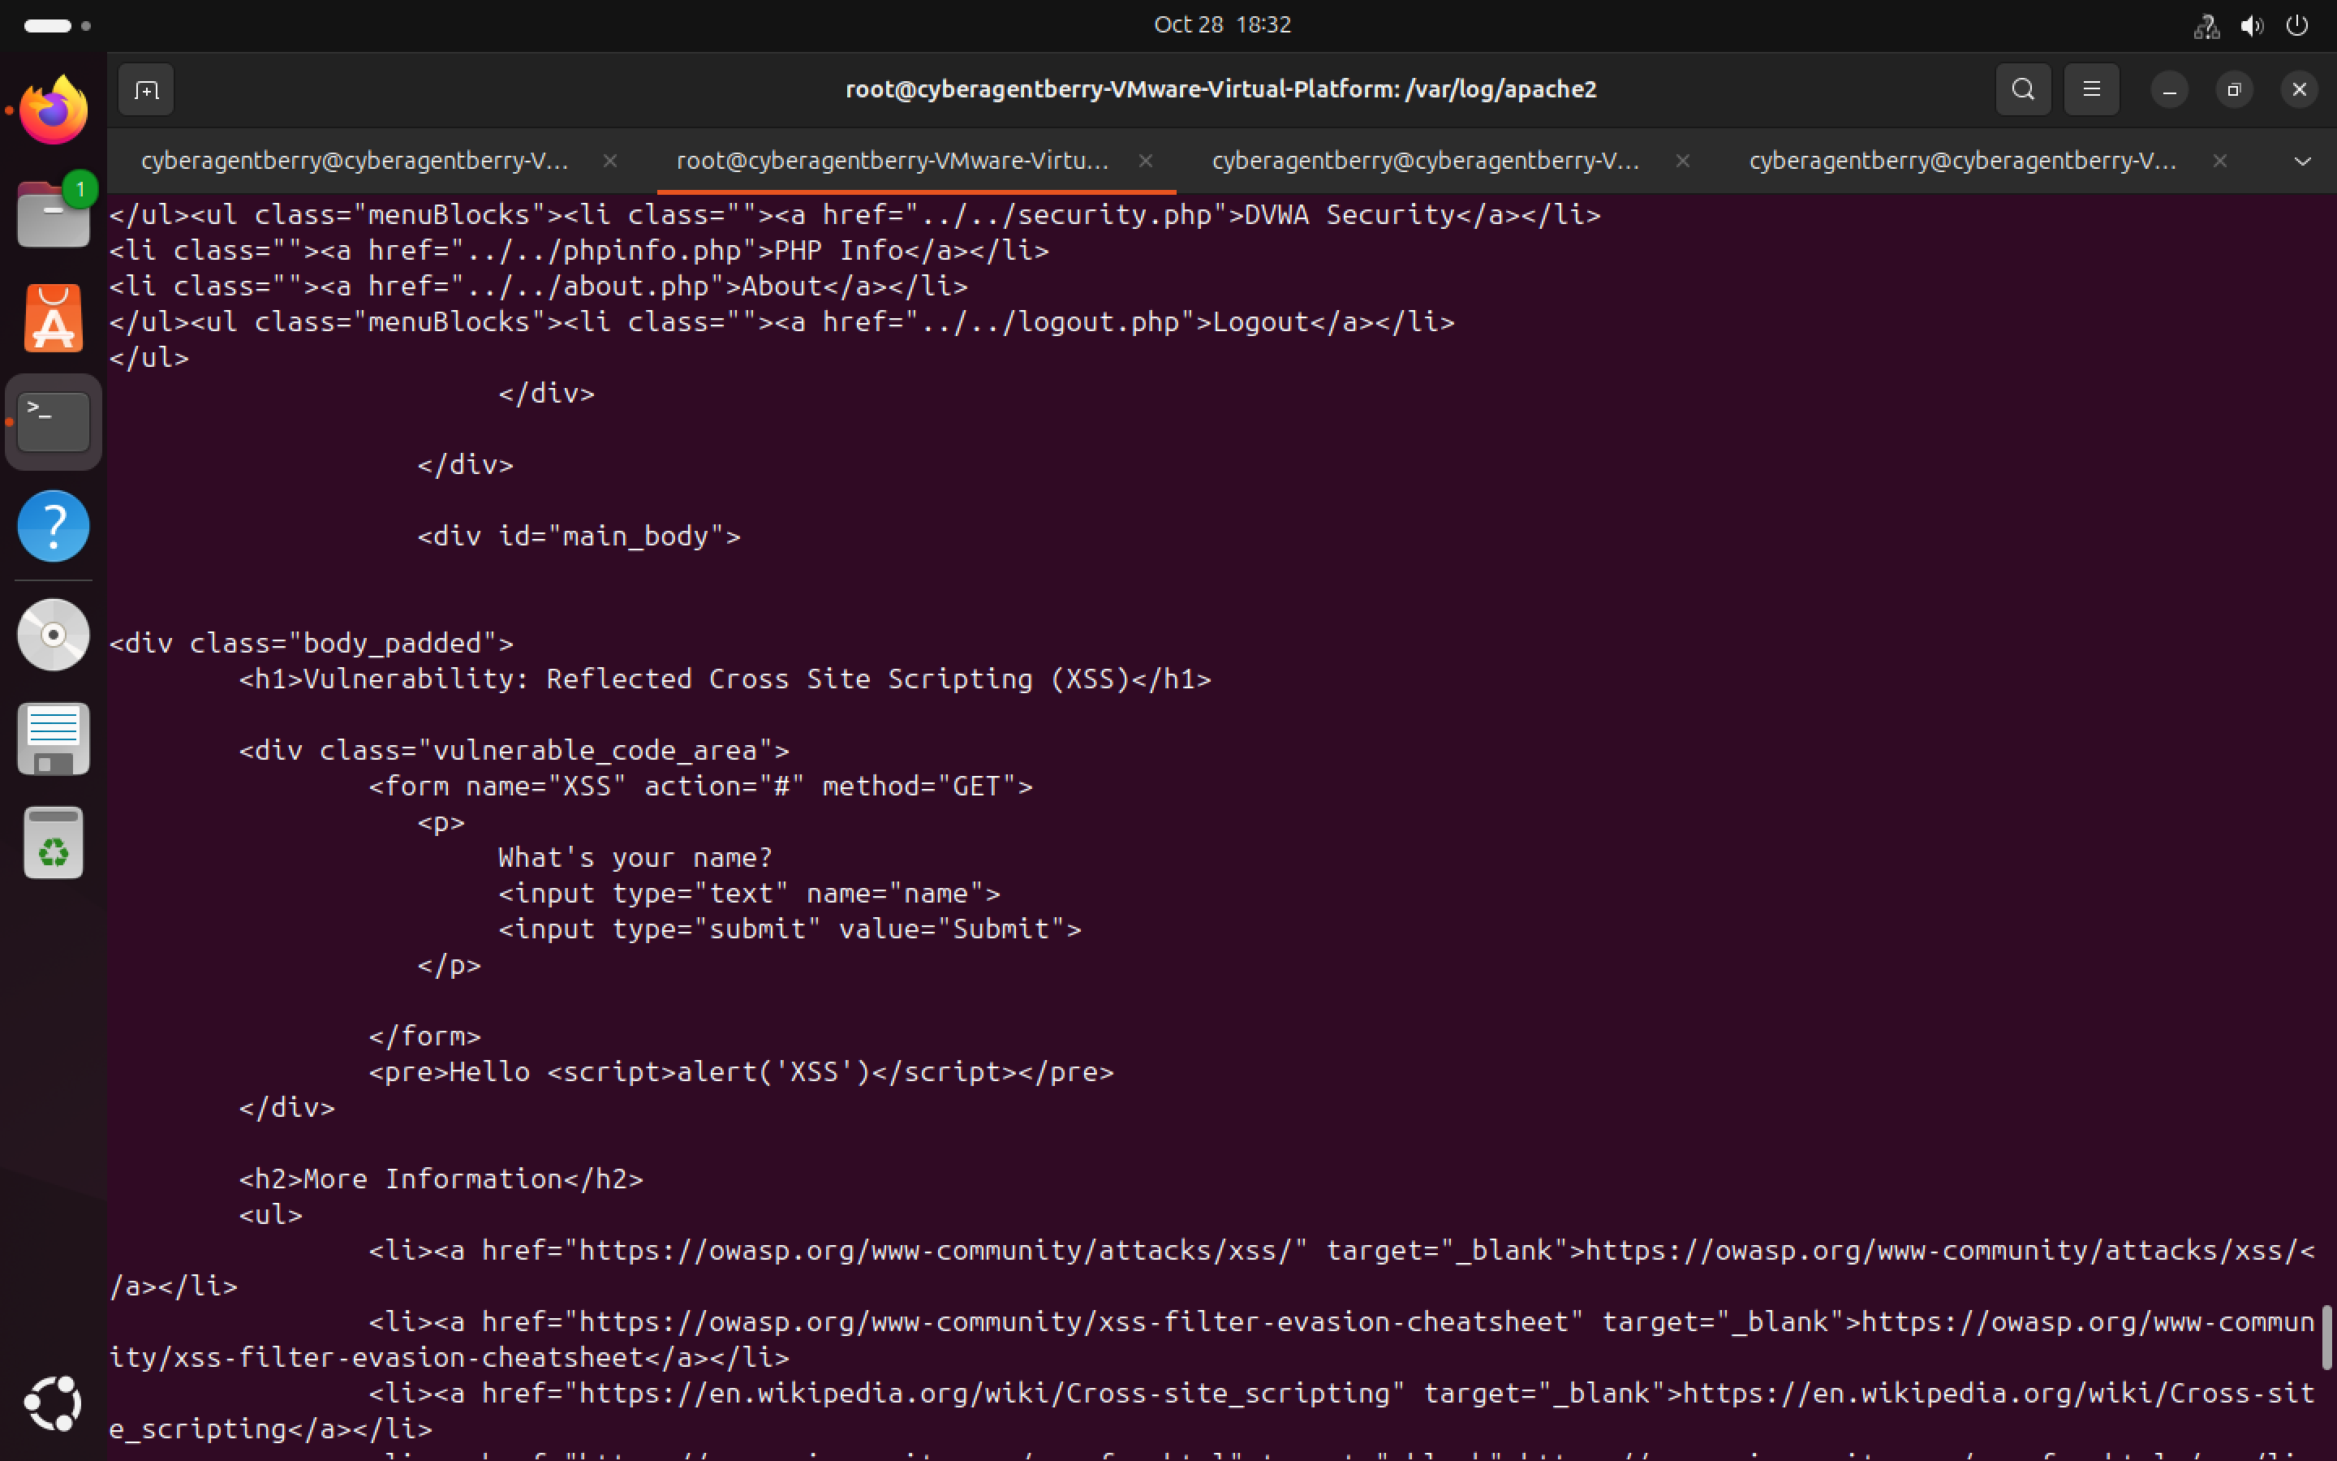

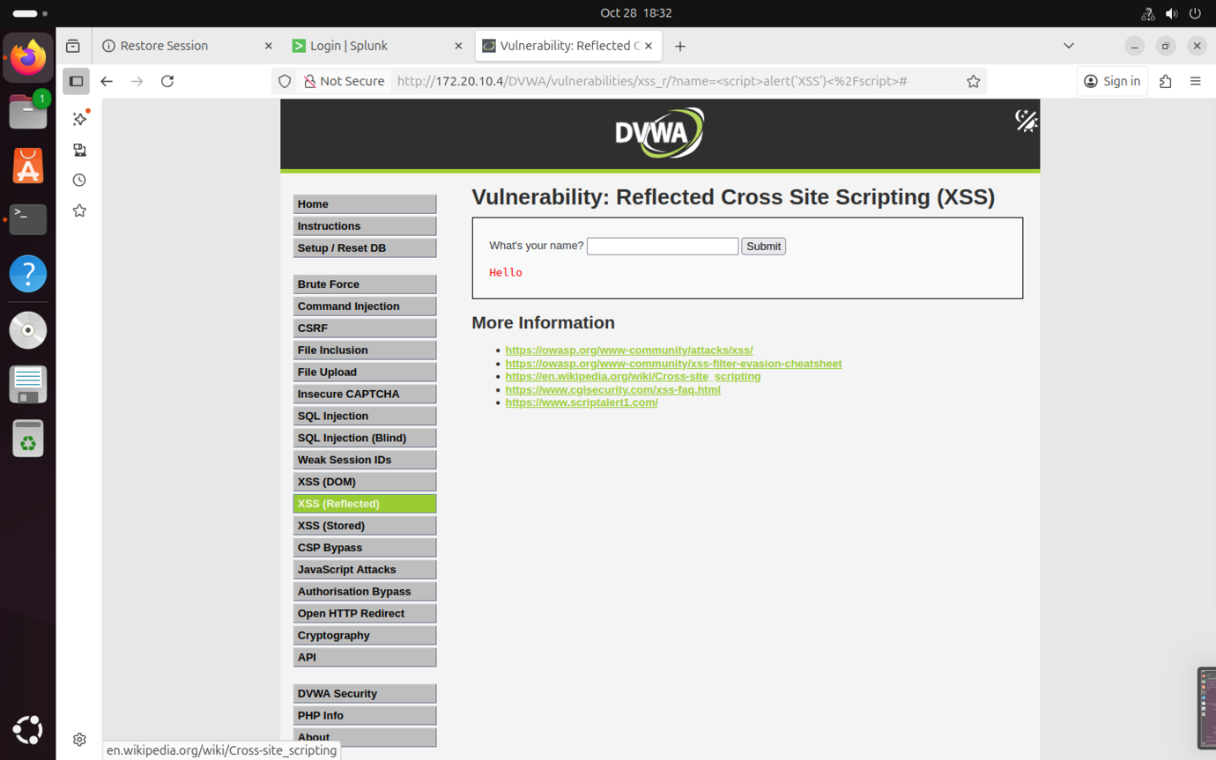

Custom Detection Rules — Implementation & Test

SQLi

SQL Injection is a **web application vulnerability** that lets an attacker insert (inject) malicious SQL code into a query that the application sends to the database.

When a web app takes user input and directly adds it into an SQL query **without sanitizing or validating it**, attackers can manipulate the query by doing so they can:

* Bypass login
* Read sensitive data
* Delete or modify data
* Add new admin users
* Take over the entire database

Test:

A set of conservative local ModSecurity rules to detect SQL injection patterns specific to DVWA were implemented. Rules were saved in: /etc/modsecurity/rules/local_rules.conf and initially configured in DetectionOnly mode to log matches (IDs 1001001–1001005).

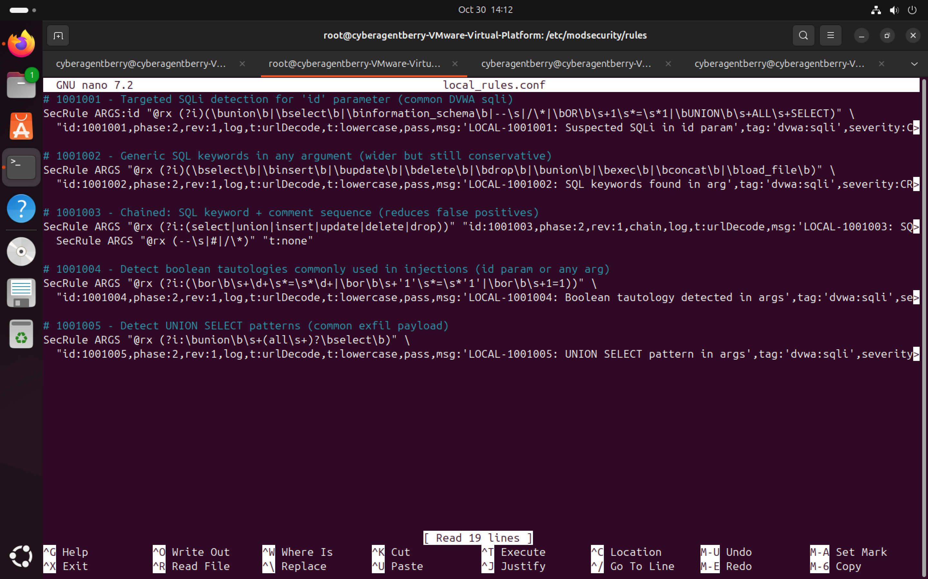

During testing of /DVWA/vulnerabilities/sqli/ the custom local detection rules fired on the canonical payload 1' OR '1'='1' --. The ModSecurity audit log recorded two local rule matches:  **LOCAL-1001001** (“Suspected SQLi in id param”) and **LOCAL-1001004** (“Boolean tautology detected in args”). DVWA debug output confirmed the executed query:  
SELECT first_name, last_name FROM users WHERE user_id = '1' OR '1'='1' -- ';  
This proves the application-level injection succeeded. ModSecurity was in **DETECTION_ONLY** mode and logged the events; no blocking occurred.

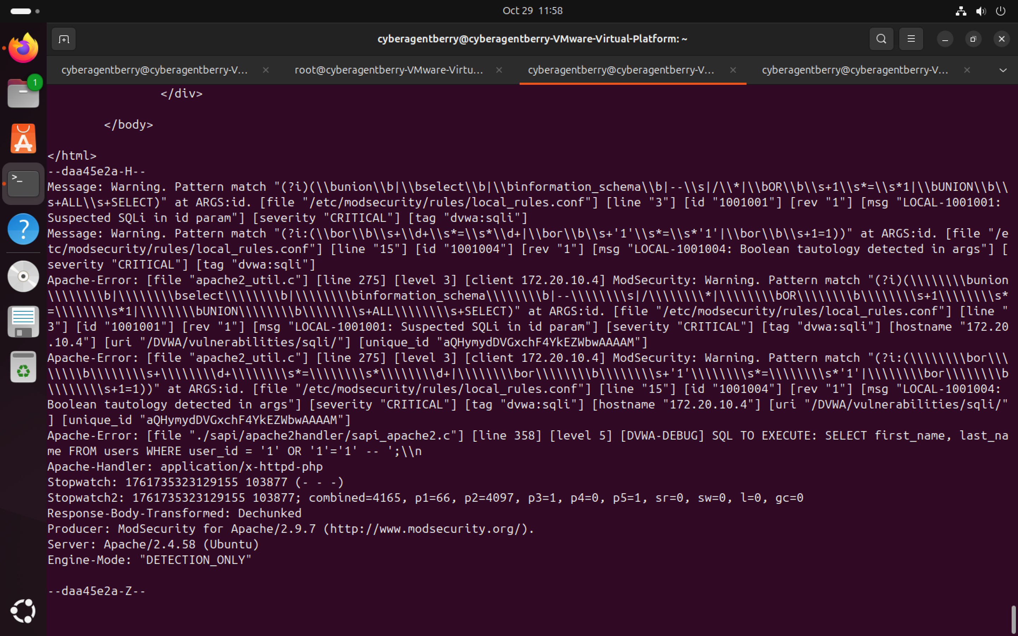

Log from /var/log/apache2/modsec_audit.log

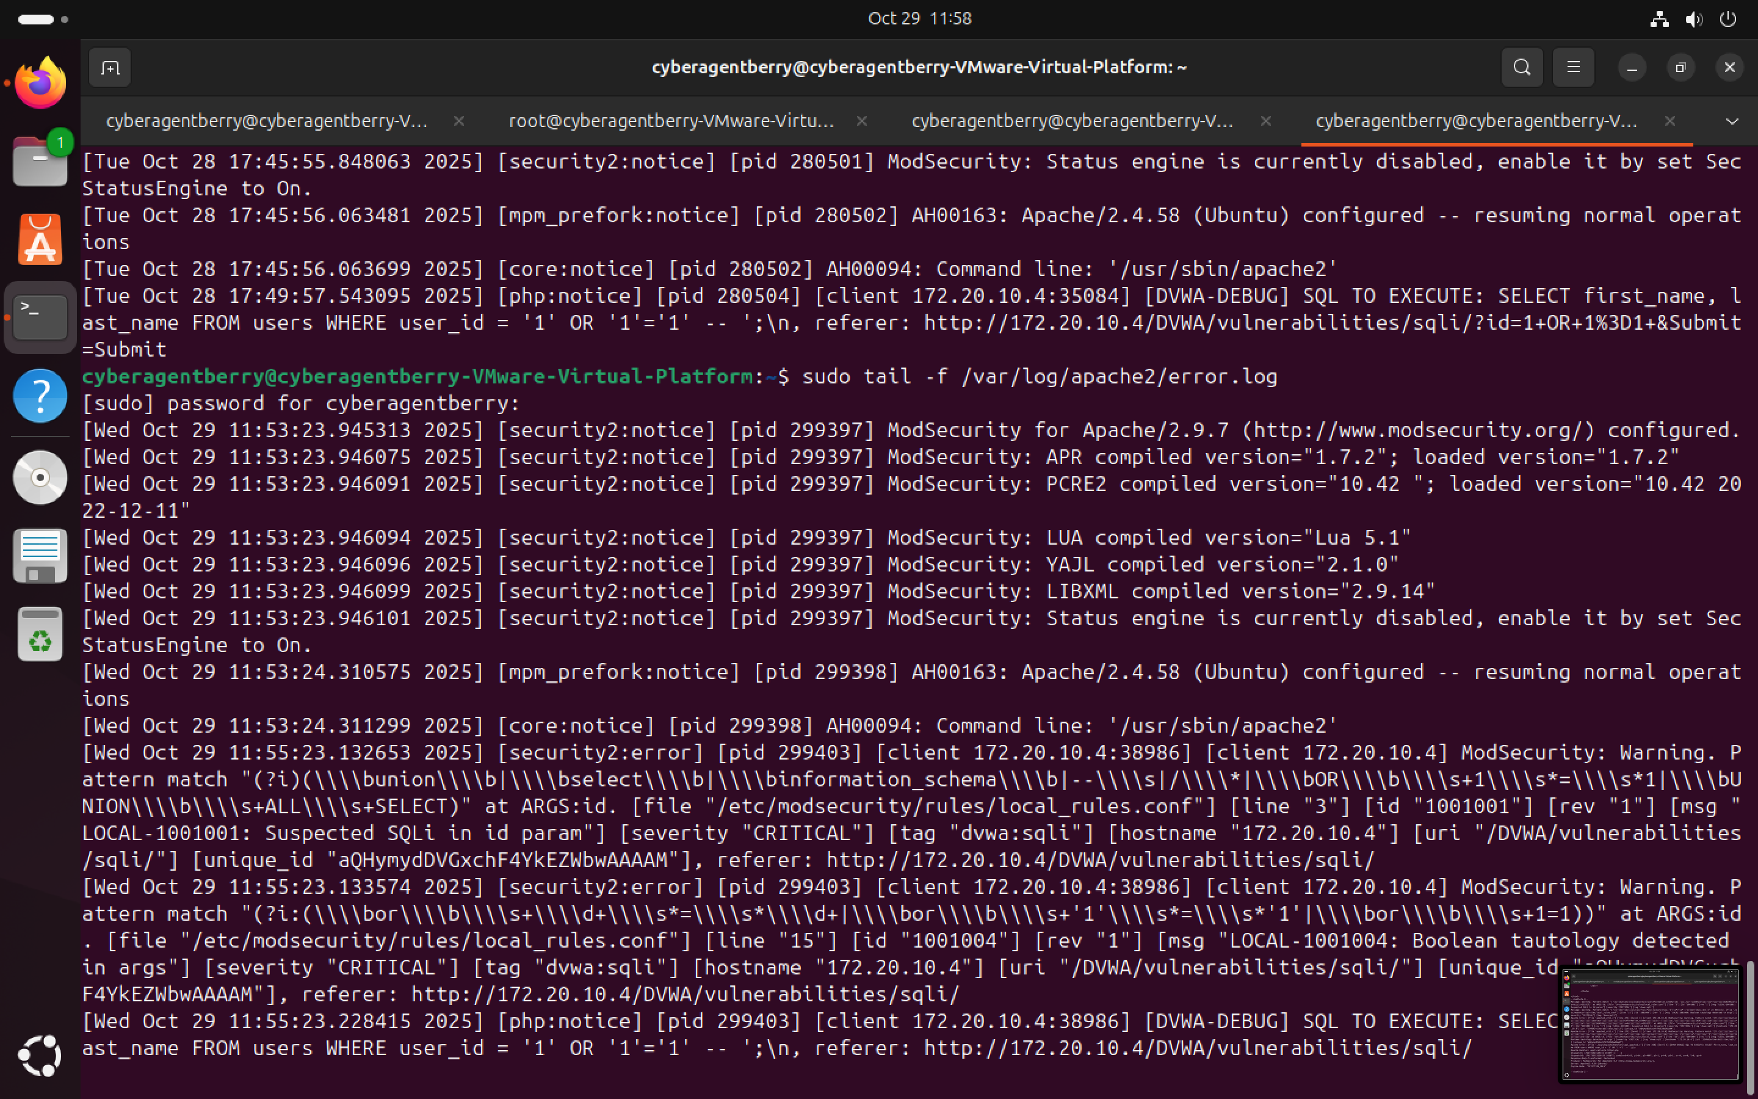

Log from /var/log/apache2/error.log

Mitigation Strategies

1. Use Prepared Statements/Parameterized Queries: Ensure user input is never concatenated directly into SQL queries.
2. Stored Procedures: Encapsulate SQL logic inside the database and pass only parameters from the app.
3. Input Validation & Sanitization: Validate input types, length, and format (e.g., only allow alphanumeric usernames).
4. Least Privilege Database Access: The application account should have only the permissions it needs.
5. Web Application Firewall (WAF): Use rules to detect common SQLi patterns (like ' OR '1'='1) and block them.

XSS – Cross Site Scripting

XSS is a vulnerability where an attacker injects **malicious JavaScript** into a web page that is viewed by other users. Malicious actors can:

* Steal session cookies
* Hijack user accounts
* Redirect users to malicious sites
* Deface websites
* Run any JavaScript in the victim's browser

Test:

A set of conservative local ModSecurity rules to detect XSS patterns specific to DVWA were implemented. Rules were saved in: /etc/modsecurity/rules/local_rules.conf and initially configured in DetectionOnly mode to log matches (IDs 2002001–2002004).

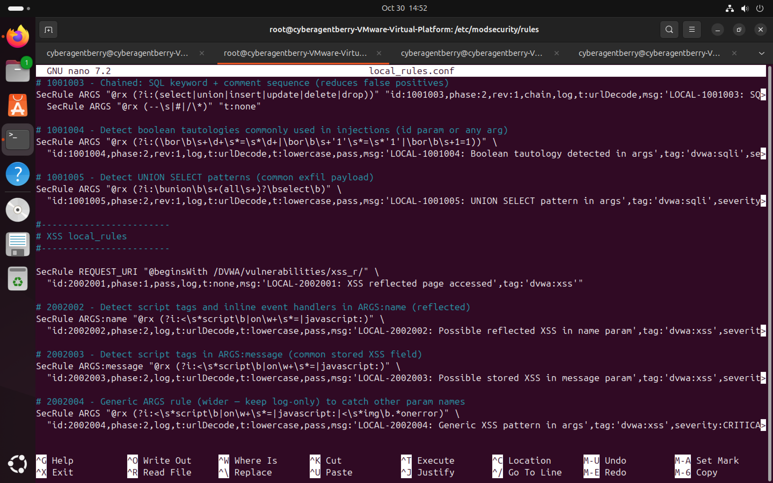

**Reflected XSS test —** /DVWA/vulnerabilities/xss_r/

**Payload:** <script>alert('XSS')</script>  
**Procedure:** The payload was submitted in the name parameter with ModSecurity in DETECTION mode ONLY.

**Result:** The browser executed the payload (alert), confirming reflected XSS. The ModSecurity audit log recorded a local detection rule match **LOCAL-2002002** for ARGS:name showing the payload.

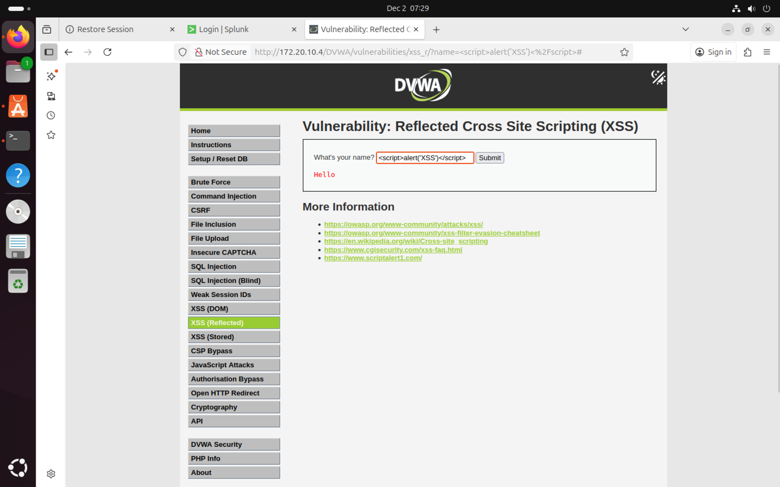  
A Screenshot of the Payload in the Name field and the “Hello” message showing a successful payload injection.

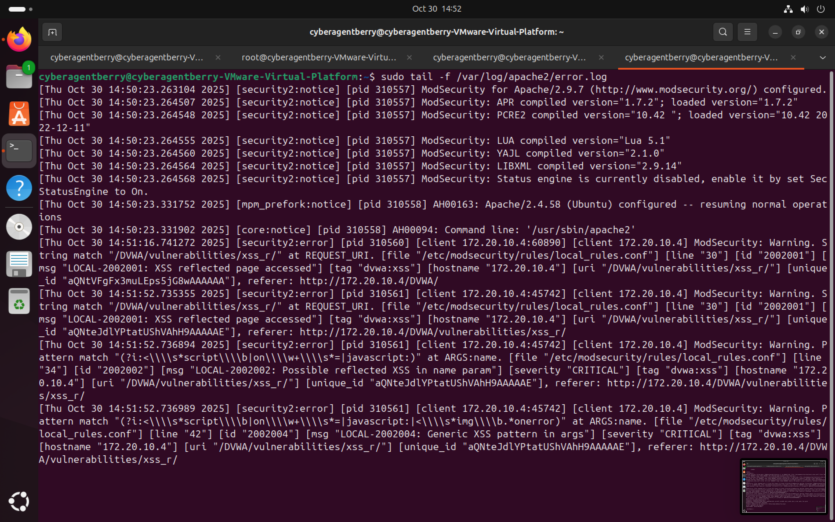

Logs from /var/log/apache2/error.log

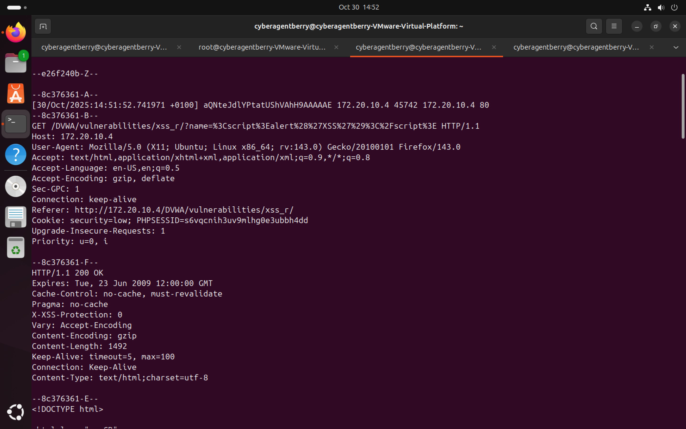

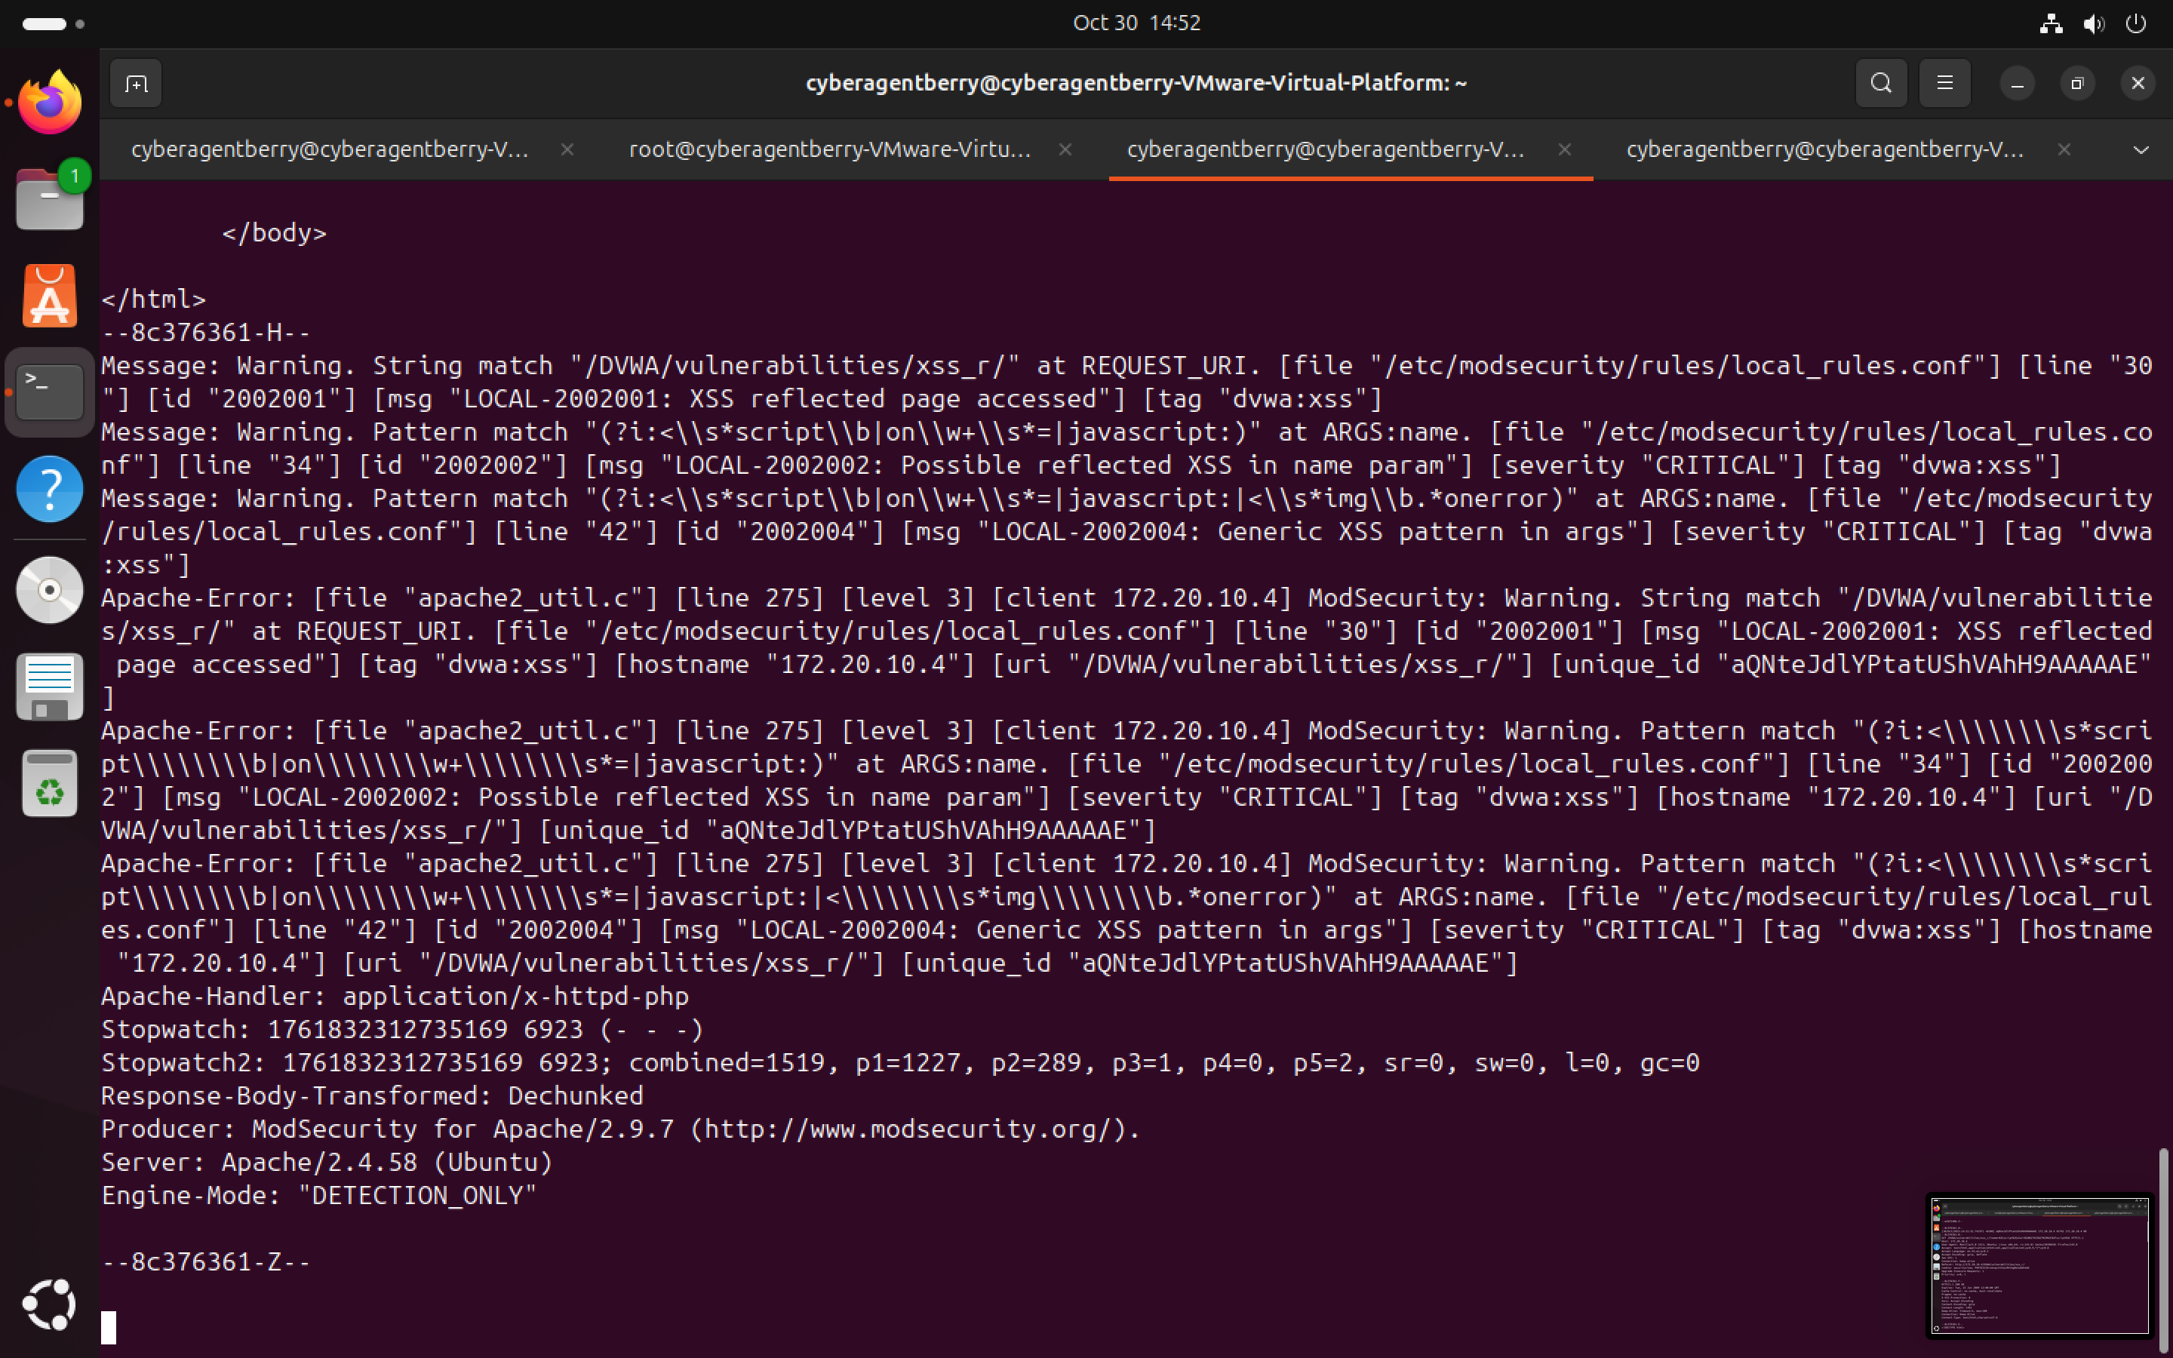

Log from /var/log/apache2/modsec_audit.log

Mitigation Strategies:

1. **Output Encoding / Escaping**: Encode user-supplied data before displaying it on the page.
2. **Content Security Policy (CSP)**: Restrict which scripts can run on your site to reduce impact of injected scripts.
3. **Input Validation**: Allow only expected characters, especially in text inputs.
4. **Avoid Dangerous Functions**: Avoid eval(), innerHTML with untrusted input, or document.write() with user data.
5. **HTTP-only Cookies**: Prevent JavaScript from accessing cookies to protect session tokens.

Cross Site Request Forgery (CSRF)

CSRF is an attack where a malicious website tricks a logged‑in user’s browser into sending **unauthorized requests** to another website where the user is authenticated.

Test:

A malicious html page was created and saved as csrf_attack.html in the /var/www/html directory. The CSRF attack page was opened using http://localhost/csrf_attack.html.

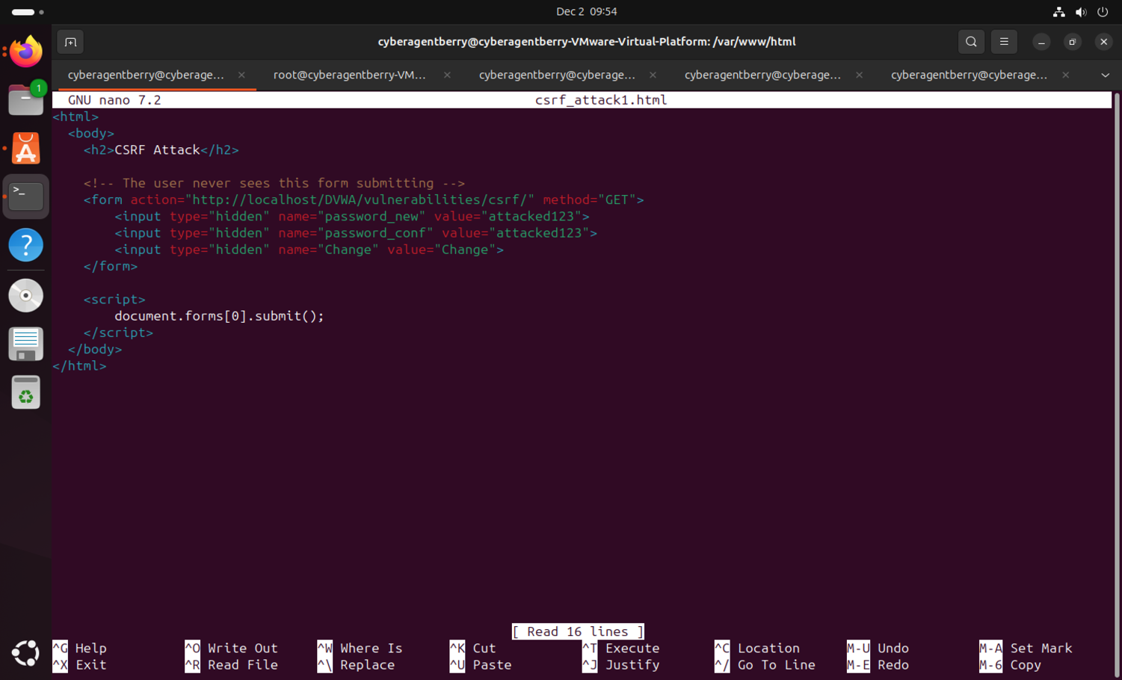

Logged in as an admin on DVWA, opened the attacker page in the browser and the browser auto-submitted the hidden form to DVWA. This request was accepted since there was no CSRF token, no session validation beyond cookies, no old password requires and no origin.

The account password was successfully changed to attacked123 without user interaction, demonstrating a full CSRF Vulnerability and the custom-based rule was triggered.

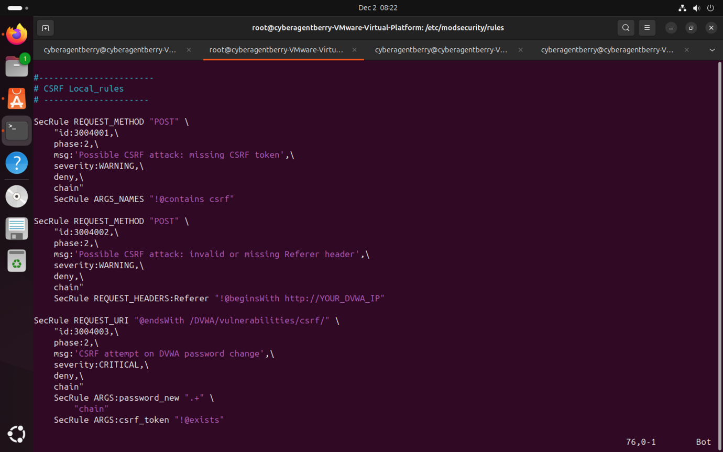

CSRF Modsec local rules

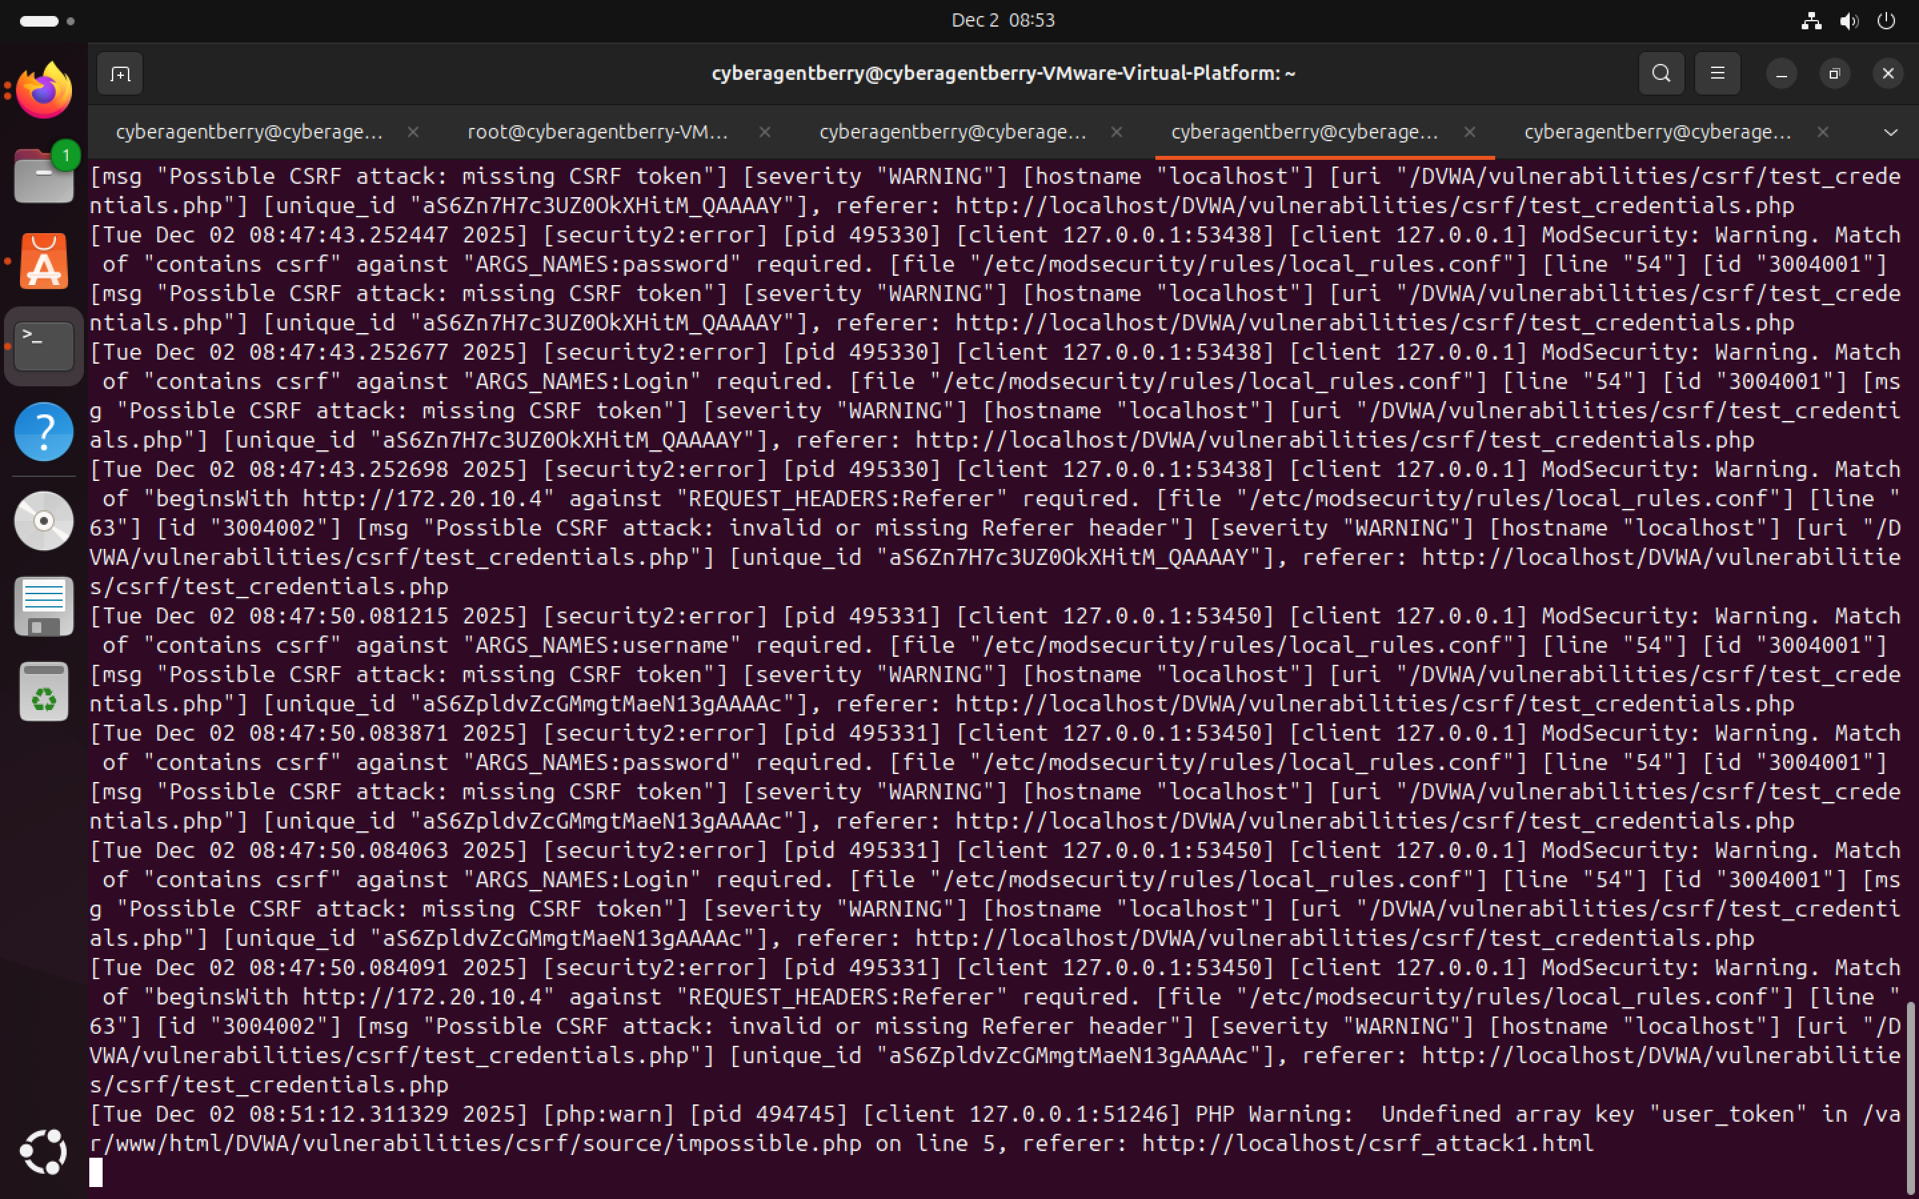

Logs of the triggered CSRF rules from /var/log/apache2/modsec_audit.log

Mitigation Strategies:

1. **Use CSRF Tokens**: Include a unique token in every form or state-changing request and verify token on the server before processing the request.
2. **SameSite Cookies**: Set session cookies with SameSite=Strict or SameSite=Lax to prevent cross-site requests.
3. **Double Submit Cookie Pattern**: Send the token both as a cookie and a form field, and verify they match.
4. **Re-authentication / Confirmation for Sensitive Actions**: Ask for password input or confirmation for important actions like money transfers or password changes.
5. **Check Referer / Origin Header**: Confirm requests come from your own domain.

Problem Encountered

1. Empty ModSecurity Configuration File

During the configuration phase of ModSecurity, I observed that the primary configuration file (/etc/modsecurity/modsecurity.conf-recommended) was completely empty. This prevented ModSecurity from operating properly, as it relies on this file to define its security engine behavior (e.g., detection or blocking mode).

The issue occurred because the package installation did not include the default configuration template.

Solution

To resolve the problem, I reinstalled the ModSecurity package using the command:

sudo apt-get install --reinstall libapache2-mod-security2 -y

This restored the missing configuration file. The recommended configuration was then copied to the active configuration path (/etc/modsecurity/modsecurity.conf) and edited to enable DetectionOnly mode by setting:

SecRuleEngine DetectionOnly

After saving the file and restarting Apache, ModSecurity began successfully inspecting HTTP traffic.

2. While setting up ModSecurity with the OWASP Core Rule Set (CRS), the Apache web server failed to start and displayed the error:  
“ModSecurity: Found another rule with the same id”. This occurred because two CRS directories (/etc/modsecurity/crs and /usr/share/modsecurity-crs) were being included simultaneously, causing duplicate rule IDs to load.

**Solution:**  
The issue was resolved by editing the security2.conf file and commenting out the redundant include line (IncludeOptional /usr/share/modsecurity-crs/*.load). This ensured that only one CRS rule set (located in /etc/modsecurity/crs/) was loaded. After saving the changes and restarting Apache, the service started successfully.

3. **Observed issue and resolution during SQLi testing:** During SQL injection testing against DVWA’s low-level sqli page, initial payloads caused a 500 Internal Server Error. Apache error logs showed a mysqli_sql_exception reporting malformed SQL near 1' OR 1=1 --''.   
  
Solution: Investigation revealed the error was due to an incorrectly formed SQL comment: in MySQL the -- comment token requires a trailing space (-- ). The injected string therefore did not comment out the remaining quote and produced invalid SQL. I corrected the payload to 1' OR '1'='1' -- (with a space after --) and re-ran the test. The corrected payload produced valid SQL injection behaviour and allowed ModSecurity audit logs to be collected for detection analysis.

CONCLUSION

This project focused on analyzing common web vulnerabilities like S**QL Injection, XSS, and CSRF** and securing a web application using **ModSecurity**. By testing these attacks on a vulnerable application, it was possible to see how easily data and user accounts could be compromised if proper defenses are not in place.

Custom ModSecurity rules were implemented and tested, successfully **detecting and blocking malicious requests**, which prevented unauthorized actions and protected sensitive information.

The project also showed the importance of **secure coding practices, input validation, output encoding, and session management** alongside web application firewalls. Overall, it demonstrates that **proactive testing and layered security measures** are essential to keeping web applications safe.